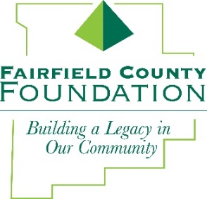
NEWS RELEASE
FOR IMMEDIATE RELEASE October 5, 2017

Fairfield County Foundation Announces New Grant Deadlines for 2018

LANCASTER, Ohio –In an effort to create more opportunities throughout the year for local organizations to apply for grants and minimize the amount of time between cycles, the Fairfield County Foundation recently announced that they will implement three grant cycles starting in 2018.
“We're excited to announce that there will be more opportunities for local organizations to apply for and receive grants from the Foundation,” said Amy Eyman, Executive Director of the Fairfield County Foundation. “We are always seeking ways to assist our area nonprofit organizations in fulfilling their missions and we hope that this change will allow more organizations to take advantage of the funds available through our grant program.”
Following are the deadlines for the 2018 grant cycles:

CYCLE 1:
- Preliminary Grants: Due second Monday of January - January 8, 2018
- Invitations to submit full grant sent second week of January
- Grant Application: Due second Monday of February - February 12, 2018
- Grant Committee recommendation to Board of Trustees for approval - March 15, 2018
CYCLE 2:
- Preliminary Grants: Due second Monday of May - May 14, 2018
- Invitations to submit full grant sent second week of May
- Grant Application: Due second Monday of June - June 11, 2018
- Grant Committee recommendations to Board of Trustees for approval - July 19, 2018
CYCLE 3:
- Preliminary Grants: Due second Monday of September - September 10, 2018
- Invitations to submit full grant sent second week of September
- Grant Application: Due second Monday of October - October 8, 2018
- Grant Committee recommendations to Board of Trustees for approval - November 15, 2018
To view grant guidelines and preliminary grant application, visit http://www.fairfieldcountyfoundation.org/grants/
About the Fairfield County Foundation:
The Fairfield County Foundation is a 501 © (3) non-profit that along with its supporters, helps to sustain and enhance the quality of life and economic viability in our community. Its scholarship program helps to sustain opportunities for local youth to achieve their academic goals. The Foundation was formed in 1989 and grants today continue to support the arts, children’s programs, health and wellness projects, community development, academics, and more. For more information, call 740-654-8451 or visit www.fairfieldcountyfoundation.org.
###
MEDIA CONTACT: Jill Buterbaugh, 614/326-9054, jill@krilecommunications.com

