**Grant**

**Guidelines**

**_________________________________________**

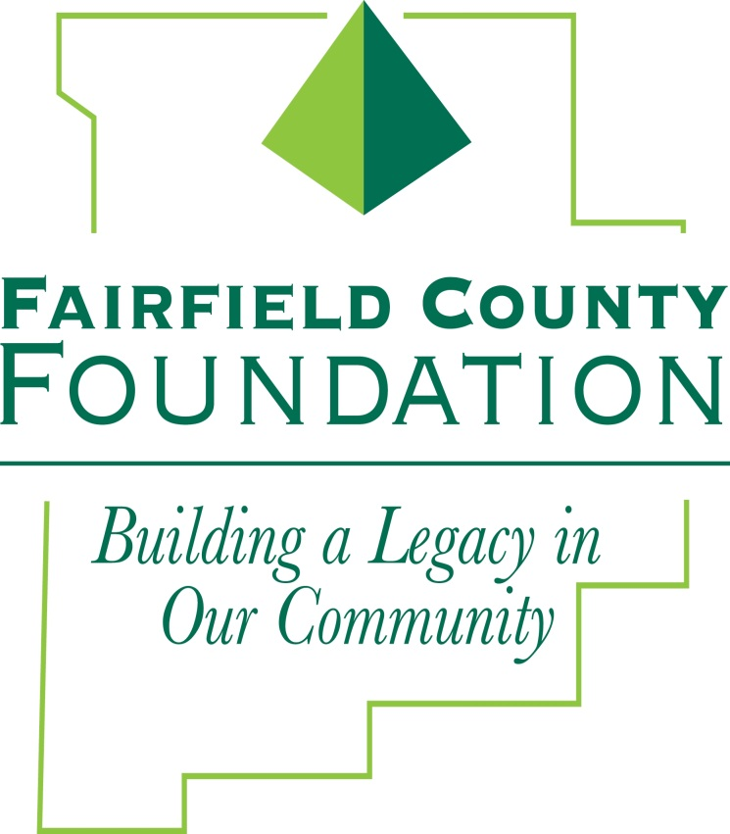

162 East Main Street

Lancaster, Ohio 43130

740-654-8451

www.fairfieldcountyfoundation.org

**GRANT GUIDELINES**

**About the Foundation**

The **Fairfield County Foundation**, a community foundation, was established in 1989 in Lancaster, Ohio as a 501(c)(3) not-for-profit corporation to serve the entire community. The Foundation was established in order to afford an opportunity for individuals and others to financially assist non-profit organizations within our community.

The **Fairfield County Foundation** is responsible for both restricted and unrestricted funds. Restricted funds have specific directions, which were given at the time the fund was established, and the Board of Trustees may only approve grants in accordance to the donors’ direction. In addition, there are unrestricted and field of interest funds, which may be used to respond to community grant applications.

The **Fairfield County Foundation** is committed to providing effective and efficient management of the funds under our care through wise investment, careful consideration of the community’s needs and evaluation of the impact of each distribution.

The **Fairfield County Foundation** encourages 501(c)(3) nonprofit organizations or government agencies in the Fairfield County area to partner with the foundation in meeting its mission and to apply for assistance through Foundation grants when appropriate. The partnering organization should be located in Fairfield County or be able to demonstrate that a significant number of people or clients served by the organization reside in Fairfield County.

**Grant-Making Program Overview**

The **Fairfield County Foundation’s** grant-making program is comprised of the following components: Designated, Donor Advised, Agency Endowment, and Discretionary/Unrestricted funds.

**Agency Endowments, Designated Grants** (*or, Restricted Grants*), and **Donor Advised** grants are distributed according to recommendations by donors and fund representatives. **Applications are *not* accepted for grants from these Fund types.**

**Discretionary Grants** are distributed from funds that are *unrestricted* or directed to a broad area or *Field of Interest.* The Fairfield County Foundation’s Board of Trustees, following recommendations of the Grant Committee, awards funds to nonprofit organizations that enhance the quality of life for Fairfield County residents. **Applications are *accepted* for Discretionary Grants.** Discretionary funding is available through Unrestricted Funds, Field of Interest Funds or Donor Advised Funds at the request of the donor.

The Foundation’s Board and staff review these programs annually. Funding priorities are adjusted as needed, based on our growing asset base and the changing needs of our community.

**Funding Priorities**

** Arts and Culture:** To preserve and enhance arts and cultural heritage and institutions, expand access to arts and cultural offerings to new audiences, provide creative educational experiences for children and families, and encourage innovation and creativity. Areas of funding include: performances, exhibits, programs, projects, supplies, etc..

**C:\Users\Amy\AppData\Local\Microsoft\Windows\Temporary Internet Files\Content.IE5\070X1L81\MC900055033[1].wmf Civic and Community:** To support youth involvement in activities and for the basic needs of youth. To encourage more efficient use of community resources to coordinate, cooperate and share among organizations. To eliminate duplication of services and to build the capacity of organizations and communities to solve problems. Assistance in areas of economic development, public safety, civic improvement, justice and promoting the community.

**C:\Users\Amy\AppData\Local\Microsoft\Windows\Temporary Internet Files\Content.IE5\W06VGPGW\MC900056116[1].wmf Education:** To increase early education and care; language and reading readiness; keeping children in school; family literacy/adult education. Funds to enhance the experience of students directly, or to provide additional resources for educational programs.

** Environment:** To improve and preserve the quality of environmental conditions for current and future generations, preserve and beautify open spaces and gardens, conserve natural resources, and encourage citizen involvement in environmental protection activities. This area includes funding for parks, natural resources, and animals.

** Health:** To improve access to and quality of treatment services, promote health and wellness, and promote the efficient use of healthcare resources. Support for medical programs and facilities.

 **Human Services:** To support those agencies that strengthen the quality of individual and family life by responding to personal and family emergencies, intervening early when individuals and families are at risk of serious problems, and providing for basic needs when individuals and families cannot provide for themselves.

Addresses basic human needs of food, shelter, clothing and seeking solutions to social problems.

These descriptions are not meant to provide an exhaustive list of all activities the Fairfield County Foundation will support. We encourage you to call our office at 740-654-8451 to discuss whether your ideas fit within our guidelines with our Program Officer, Abby King, prior to filling out an application. You may also email aking@fairfieldcountyfoundation.org to discuss grant projects. The Fairfield County Foundation is willing to consider any proposal that could have a major impact on our community, especially if funding is not available from any other source.

**ELIGIBILITY FOR FUNDING**

The Fairfield County Foundation makes grants to tax-exempt 501(c)(3) organizations and government agencies operating or proposing to operate programs/projects that benefit Fairfield County residents. While the Foundation would like to support all the important work that is carried out by Fairfield County’s organizations, its financial resources are limited. Therefore, decisions about funding projects that are submitted by grant applicants will be made with the following guidelines in mind:

***The Fairfield County Foundation has a preference for proposals that:***

• Develop innovative, creative, and practical solutions to both current and emerging community needs.

• Create programs that enhance the quality of life for a substantial number of people, for seed money or a start- up.

• Encourage volunteerism, civic and community involvement.

• Facilitate compassion, efficiency, and responsibility in the distribution of social services to the community.

• Support projects that create a long-term physical community resource.

• Demonstrate that the funds will be well-managed and effectively expended and that the project will become self-supporting when grant dollars end.

• Play a role in assuring mutuality of interest, efficiency, and the elimination of duplication of services.

• Utilize matching funds- a project in which the Foundation is a partner, rather than the sole funder.

***The Fairfield County Foundation normally does not fund:***

• Ongoing operating expenses, including salaries, utilities, and annual campaigns

• Projects that promote any specific religion or belief

• Budget deficits or debt reduction

• Lobbying and/or political activity

• Endowment funds

• Capital improvements to buildings and property not owned by the organization or covered by a long-term lease

• Work or projects that are already underway or have been completed

• Grants to organizations that have received a Fairfield County Foundation grant for the same or a similar project in the last 12 months

• Service organizations, Booster clubs or National Organizations without a local chapter

• Services, equipment, or infrastructure normally expected to be funded by taxpayers

To discuss your grant request, contact our Program Officer, Abby King, Monday through Friday between 9:00 a.m. and 4:00 p.m. at 740-654-8451 or by email at aking@fairfieldcountyfoundation.org.

**Applying for a Grant**

**The Grant-making Process**

Our goal is to make the grant writing process smooth and easy. Nonprofit organizations designated 501(c)(3) by the Internal Revenue Service or government agencies physically located in and serving Fairfield County, Ohio are eligible to apply for a grant. As of 2022 the Foundation’s grant making process is fully done online. Interested parties may preview the applications and documents by visiting our website prior to creating a login at www.fairfieldcountyfoundation.org/grants.

**To apply for a grant, please follow these steps:**

1. **Call the office or email Program Officer**, Abby King (aking@fairfieldcountyfoundation.org), of the Fairfield County Foundation to discuss your grant request idea and whether your project appears to fit within the Foundation’s guidelines.
2. **Complete the Preliminary Application/LOI online** by the second Monday of January, May, or September.
3. If our Grant Committee confirms that your project fits within our guidelines and would like to learn more, **you will be asked to submit a Grant Application in our online system** by the second Monday of February, June, or October. As of 2022 this notice will come via email used to submit the preliminary application/LOI in our online system.
4. The Grant Committee may ask for additional information, an interview**, or a site visit**, if necessary. After site visits have been completed, the Grant Committee will meet and review each site visit report and then determine what recommendations to make to the full Board. Once the Board has approved the recommendations of the grant committee, your organization will be notified by email of the Board’s decision. Included in this notification will be a link to the online **Grant Agreement** which must be signed and submitted in the Foundation’s online grant system.
5. **Final decisions** will be made by the Board of Trustees at their March, July, or November meeting.

**Grant Terms**

Grant awards will be paid as follows: Once you are notified that your grant has been approved, you will be required to *complete a Grant Agreement Form* in our online grant system. Please submit the Grant Agreement within 10 days of being notified. Once you are ready to begin your project and purchase the items you must fill out and submit the Fund Request in the Foundation’s online grant system.

All grants must be accepted within 10 days and used within 6 months of awarding; however, an organization may arrange additional time in which to use the funds, with written approval by the Foundation’s Executive Director or Program Officer.

**Organizations that reach the grant application stage may apply only once within a calendar year for grants from discretionary/unrestricted funds (exceptions may be made in cases where one nonprofit serves as fiscal agent for another organization).**

In general, the Fairfield County Foundation awards grants for a period of one year.

In selected instances, the Foundation will accept requests for multi-year grants up to a maximum of three years. An application seeking multi-year support must meet the following conditions:

1. Demonstrate that multi-year support is essential to the start-up of a new initiative.
2. Demonstrate that the effort will produce specific, measurable outcomes within the agreed-upon time period.
3. Agree to participate in a formal, annual evaluation to document and measure the proposed outcomes.

The Board of Trustees has the right to make exceptions to the funding timelines or grant terms.

**Grant Management**

Organizations interested in Fairfield County Foundation funding should understand the requirements for maintenance and reporting for grant awards.

**Maintenance and Grant Reporting**

Grant recipients are expected to give credit to the Fairfield County Foundation in publications, press releases, and where appropriate with a plaque or naming rights.

In addition, the Fairfield County Foundation requires a Final Grant Report to be submitted to the Foundation once the funding is exhausted, to include final receipts of items purchased, any announcements of the funding to the public and pictures. Additional reporting may be required, at the request of the Foundation offices, as a final report on the funded project. Returning applicants who did not complete their previous grant requirements and required paperwork will not be considered for future funding.

Foundation representatives may also request a follow up site visit. The purpose of the site visit is to learn more about the project funded and to see and learn the impact of the grant to those that it serves.

You are encouraged to maintain communication with Foundation staff and are invited to share photos and stories that demonstrate the success of your programs. From time to time, the Foundation has opportunities to publicize nonprofit organizations and projects funded in our newsletters and annual report, or on our website. You will be contacted for information prior to publication of these items.