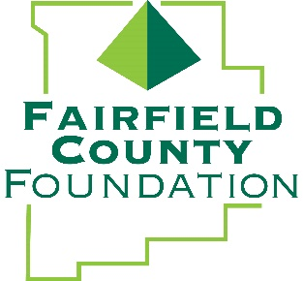

NEWS RELEASE
Fairfield County Foundation Raises $95,809 with “29-Hour Give” Event

November 30, 2018 -- LANCASTER, Ohio – The Fairfield County Foundation hosted its annual “Get Your Give On” event this week in conjunction with #GivingTuesday, which takes place annually on the Tuesday after Thanksgiving (in the U.S.) to kick-off the holiday giving season and inspire people to collaborate in improving their local communities.
This year’s 29-Hour Give event was the most successful yet, with the Foundation raising a record $95,809 during the 29-hour time window that began Tuesday, November 27 at 8 a.m. The Foundation awarded a total of $29,000 in matching gifts to the 71 individual funds that received contributions, making the total award to participating funds $124,809.
“The unprecedented success of the 29-Hour Give is a testament to the generosity of the incredible community we call home” said Fairfield County Foundation Executive Director, Amy Eyman. “We are thrilled that the number of individual funds receiving donations rose more than 40% this year, expanding our impact significantly. We are truly grateful to our donors and supporters throughout Fairfield County who continue to rally for our community and make it such a special place.”
Non-profits and fund holders were encouraged to secure donations from individuals and have them contribute in-person or online between 8 a.m. on November 27 and 1 p.m. November 28, 2018. During the designated 29 hours, the Foundation matched funds on a pro-rata basis. For more information about the 29-Hour Give, visit: www.fairfieldcountyfoundation.org.

About the Fairfield County Foundation:
The Fairfield County Foundation is a 501 (c) (3) non-profit that along with its supporters, helps to sustain and enhance the quality of life and economic viability in our community. Its scholarship program helps to sustain opportunities for local youth to achieve their academic goals. The Foundation was formed in 1989 and grants today continue to support the arts, children’s programs, health and wellness projects, community development, academics, and more. For more information about the Foundation, please call 740-654-8451 or visit www.fairfieldcountyfoundation.org.
###
Media Contact: Jill Buterbaugh, Krile Communications, 614/326-9054, jill@krilecommunications.com

