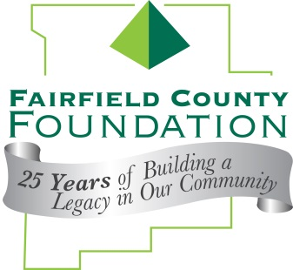
FOR IMMEDIATE RELEASE October 16, 2014

Fairfield County Foundation Announces
2014 Don C. Wendel Legacy Award Recipients

LANCASTER, Ohio --The Fairfield County Foundation today announced that the recipients of the 2014 Don C. Wendel Legacy Award are Dave and June Harcum. The Foundation presented the award at its 25th Anniversary Dinner on October 15 at The Lodge in Lancaster.

“As individuals, Dave and June’s achievements and service to our community is impressive, but as a couple, they embody the concept of synergy – having an impact that will have ripple effects for lifetimes to come,” said Amy Eyman, Executive Director of the Fairfield County Foundation. “I am honored to be able to recognize their selflessness and commitment to our community by presenting them with this award.”

Collectively, Dave and June have served as volunteers and board members of organizations that span the spectrum of the Fairfield County community – Fairfield Medical Center and the FMC foundation, Decorative Arts Center of Ohio, Lancaster Festival, Twig #7, Wilmington College, and the Fairfield County Foundation. They have established two funds within the Fairfield County Foundation including their family fund to provide contributions and grants to a variety of organizations, and a fund dedicated to addressing concerns about abuse, whether that abuse be verbal, spousal, emotional, animal, drug and alcohol, elder or disabled. In addition, they were instrumental in bringing the Child Advocacy Center to our community, which is now named Harcum House.

The Don C. Wendel Legacy Award is named for the first Chairman of the Fairfield County Foundation Board of Trustees, and was awarded. It is given to community members who have been instrumental in the success of philanthropy and who have made a significant contribution to our community. Previous recipients of the award include Judge Farrell Jackson, Robert Johnston and William Sitterley.

About the Fairfield County Foundation:
The Fairfield County Foundation is a 501 (c) (3) non-profit that along with its supporters, helps to sustain and enhance the quality of life and economic viability in our community. Its scholarship program helps to sustain opportunities for local youth to achieve their academic goals. The Foundation was formed in 1989 and grants today continue to support the arts, children’s programs, health and wellness projects, community development, academics, and more. For more information about the Foundation, please call 740-654-8451 or visit www.fairfieldcountyfoundation.org.
###

