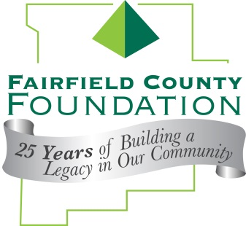
FOR IMMEDIATE RELEASE January 26, 2016

Fairfield County Foundation Welcomes New Board Members

LANCASTER, Ohio --The Fairfield County Foundation has recently welcomed three new members to its Board of Trustees, Cathy Bitler, Victor Christopher and Gerri Strigle.

“The Foundation is pleased to welcome these three members of our community to our Board of Trustees,” said executive director of the Fairfield County Foundation, Amy Eyman. “We’re looking forward to their contributions to our Foundation and our community.”

Cathy Bitler holds both a Bachelor of Science and a Master of Arts degree in Communication from Ohio University and is a graduate of the Management Internship Program sponsored at the University of Wisconsin by the National Rural Electric Cooperatives Association. She is employed as Vice President of Member Service and Community Relations at South Central Power Company. She is an adjunct faculty member at Ohio University Lancaster, teaching in the Business Management Technology program.

Vic Christopher holds a Bachelor of Science in Business Administration from The Ohio State University and has completed Advanced Accounting Courses from the University of South Florida. He is a Certified Public Accountant and a Certified Valuation Analyst. He is employed as Principal at Snyder & Company, and is a member of the American Institute of Certified Public Accountants, the Ohio Society of Certified Public Accountants and the National Association of Certified Valuators and Analysts.

For nearly 50 years, Gerri Strigle has lived and worked in Lancaster as she raised her family and dedicated her time and energy to community service. Having worked at both The Ohio State University Hospital and at medical practices in Lancaster, Gerri has a keen awareness of public health and community issues. Gerri hopes to ensure her family legacy lives on through the Fairfield County Foundation by working with the board of trustees to make sure the Strigle Scholarship is fiscally sound and available for many years.

About the Fairfield County Foundation:
The Fairfield County Foundation is a 501 (c) (3) non-profit that along with its supporters, helps to sustain and enhance the quality of life and economic viability in our community. Its scholarship program helps to sustain opportunities for local youth to achieve their academic goals. The Foundation was formed in 1989 and grants today continue to support the arts, children’s programs, health and wellness projects, community development, academics, and more. For more information about the Foundation, please call 740-654-8451 or visit www.fairfieldcountyfoundation.org.
###

