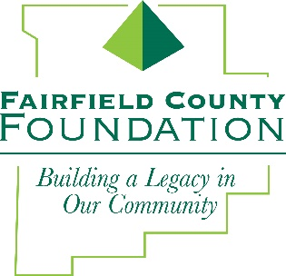
FOR IMMEDIATE RELEASE January 9, 2019

Fairfield County Foundation Welcomes New Board Members

LANCASTER, Ohio --The Fairfield County Foundation has recently welcomed four new members to its Board of Trustees: Lynn Barboza, Eileen Competti, Suzanne Lang and Joshua Moore.

“The Foundation is pleased to welcome these exceptional community leaders to our Board of Trustees,” said Amy Eyman, Executive Director of the Fairfield County Foundation. “They each bring unique experiences within our community and we’re looking forward to their contributions as members of the Foundation Board.”

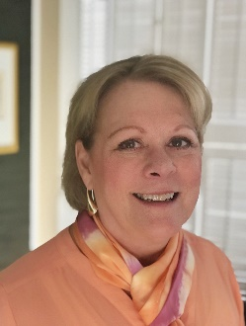
Lynn Barboza completed her associate degree in nursing at Grace Hospital School of Nursing. Lynn is a registered nurse with 30 years of experience in trauma, emergency and intensive care as well as interventional radiology and out-patient radiology. Throughout her nursing career, Lynn worked for Grace Hospital in Detroit and in Columbus at Doctors Hospital and Grant Hospital. Lynn is a nine-year member and two-year president of the Cameo League, a volunteer group of women dedicated to fundraising for the Lancaster Festival. In addition, Lynn is a dedicated board member for the Lancaster Festival Board of Directors and recently served on the Fairfield Medical Center Foundation Board. As an extension of her career caring for others, Lynn has spent nine years volunteering for the American Cancer society as a patient advocate.

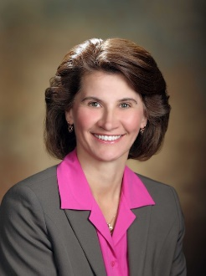
Eileen Competti earned her Bachelor of Science in Industrial Engineering from the University of Cincinnati. She obtained her Master of Business Administration from Ohio University and completed the Stanford Executive Program at Stanford University. Following a 30-year career, Eileen retired from the former Babcock & Wilcox company. She was President of Diamond Power International, Inc. from 2001 – 2012, overseeing worldwide performance of numerous domestic and international branch operations. Eileen has served as board member for global organizations within her career field, including 15 years of company board service as a BWC officer. In addition, she has served on a number of local boards, including the United Way of Fairfield County, William V. Fisher Catholic Foundation, and the Fairfield County Chamber of Commerce. Eileen is a lifelong resident of Fairfield County.
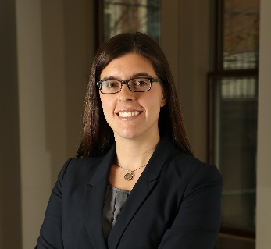
Suzanne Lang received her Bachelor of Arts in English and Psychology at Ohio University. She continued her studies at The Ohio State University’s Moritz College of Law and Capital University Law School. Suzanne is an associate at Stebelton Snider LPA, where she started as a law clerk in 2014. Prior to joining their team, she worked as a legal fellow for the Grassbaugh Veterans Project in Columbus and as a legal aid for the Western Ohio Housing Department in Dayton. Since 2012, Suzanne has been involved with the Ohio State University’s Honors & Scholars Alumni Society as a board member and past president. She is President of the Friends of Wagnalls Memorial Library in Lithopolis, is a board member for Big Brothers Big Sisters of Fairfield County and has served as a member of the Central Ohio Estate Planning Council in Lancaster since 2016.

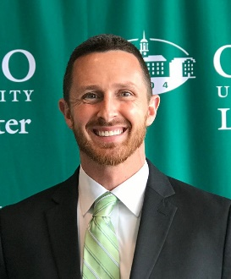
Joshua Moore completed his Bachelor of Science in Sports Management at Ohio University and Master of Business Administration from Keller Graduate School of Management at DeVry University. He is currently working to obtain his Master of Science in Higher Education from Southern New Hampshire University. Joshua is the Enrollment & Student Services Manager at Ohio University Lancaster/Pickerington, where he oversees many facets of advising and recruiting. In addition, he is an adjunct professor for Southern New Hampshire University, Ohio Christian University, and Harrison College in human relations and management subjects. Joshua is a member of The Ohio Association for Collegiate Admissions Counselors (OACAC), the National Association for College Admission Counseling (NACAC), Student Affairs Administrators in Higher Education (NASPA), and the Fairfield County College Board (FCCB).

About the Fairfield County Foundation:
The Fairfield County Foundation is a 501 (c) (3) non-profit that along with its supporters, helps to sustain and enhance the quality of life and economic viability in our community. Its scholarship program helps to sustain opportunities for local youth to achieve their academic goals. The Foundation was formed in 1989 and grants today continue to support the arts, children’s programs, health and wellness projects, community development, academics, and more. For more information about the Foundation, please call 740-654-8451 or visit www.fairfieldcountyfoundation.org.
###

