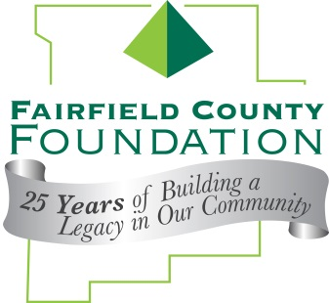
FOR IMMEDIATE RELEASE May 22, 2014

Fairfield County Foundation Celebrates 25th Anniversary
Donates more than $25,000 to Local Non Profits

LANCASTER, Ohio --The Fairfield County Foundation celebrated 25 years of building a legacy in our community last month by inviting local non-profit organizations to participate in the 25-HOUR GIVE!

“The 25-Hour Give is what our Foundation is about – bringing together donors with causes that are important to them to make an impact in our community,” said executive director of the Fairfield County Foundation, Amy Eyman. “We’re thrilled with the generous amount of donations we were able to match through this event.”

30 nonprofit organizations received part of the $25,000 match. The Foundation had $48,536.47 donated, and is matching $25,140.50 for a total of $73,676.97 going out to our community in grants.

The 25-Hour Give began at 9 a.m. on May 1, 2014 and donations were accepted until 5 p.m. The Give continued from 8 a.m. to 10 a.m. on May 2, 2014.

Organizations that benefited from this event are:

- 4-H Fairfield County Foundation Fund
- A Special Wish Foundation
- Access to Justice Fund
- Accessible Field Fund
- AHA! A Hands-On Children's Museum, Inc.
- Amy's Army Fund
- Big Brothers Big Sisters of Fairfield County, Inc.
- By The Way Medical Mission Free Clinic
- Cameo League
- Canal Winchester Human Services
- Decorative Arts Center of Ohio
- Destination Downtown
- Fairfield Center for disAbilities & Cerebral Palsy
- Fairfield County Foundation Ambassador's Fund
- Fairfield County Historical Parks District
- Fairfield Heritage Association
- Fairfield Heritage Trail Association
- Fairfield Land Preservation Endowment Fund
- Fairfield Medical Center Foundation
- Foundation Dinners
- Foundation Shelters
- Lancaster Chorale
- Lancaster Community Band
- Lancaster Fairfield Community Action
- Lancaster Fairfield County Charity Newsies
- Lancaster Festival
- Lancaster High School Class of 1957 Memorial Scholarship Fund
- Lancaster High School Class of 1959 Scholarship Fund
- Lancaster Public Education Foundation Fund
- Lutheran Social Services Fairfield County Emergency Shelters
- Lutheran Social Services Fairfield County Food Bank
- Maywood Mission
- Maywood Mission - Summer Youth Camp
- Molly Ann Clark Memorial Scholarship Fund
- New Horizons Youth and Family Center Endowment Fund
- Ohio Glass Museum
- Ohio University Lancaster Jane Johnson Center
- Ohio University Lancaster Math & Science Lab
- Ohio University Lancaster Wagner Theatre
- Pregnancy Decision Health Center of Fairfield County
- Robert K. Fox Family Y Partners Youth
- United Way of Fairfield County
- West After School Center
- Young Life of Lancaster

About the Fairfield County Foundation:
The Fairfield County Foundation is a 501 (c) (3) non-profit that along with its supporters, helps to sustain and enhance the quality of life and economic viability in our community. Its scholarship program helps to sustain opportunities for local youth to achieve their academic goals. The Foundation was formed in 1989 and grants today continue to support the arts, children’s programs, health and wellness projects, community development, academics, and more. For more information about the Foundation, please call 740-654-8451 or visit www.fairfieldcountyfoundation.org.
###

